**File system hierarchy**

Command :sudo apt install tree

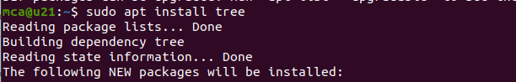

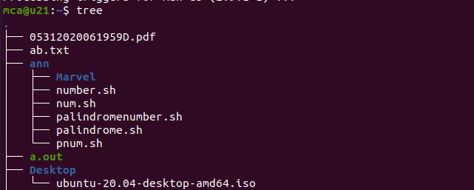

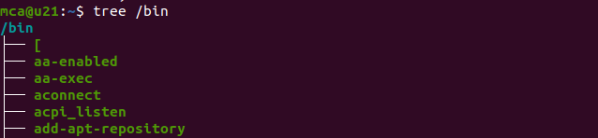

**File system hierarchy**

* **/root -** contains all other directories and files
* **/bin -** executable files , Essential binary files which are accessible to all users, These files are required for basic functioning and for various system operations and user interactions.
* **/boot -** Files required for boot process, including kernel , boot loader and initial ram disk We want to load operating System and prepare the system to use , all the files required for booting are stored in boot directory
* **/dev -** device files representing the physical and virtual devices such as harddrives, printers, cpu etc..
* **/etc -** The system configuration files for various applications and services. config -> behavior , functionality and appears of the application
* **/lib -**  libraries required in binary /bin
* **mnt, /media -** Temporary mounted files

mnt -> temporary file attachment systems , eg: External drives, network share,

media -> Temporary mount system for Removable media eg: usb , optical disk , external hard drives

* **/opt -** for storing optional packages
* **/sys -** Exposes informations about system hardware and devices
* **/tmp -** Temporary files created by users and applications
* **/usr -** user programs and libraries
* **/var -** Variable data that changes frequently such as log files and cache files